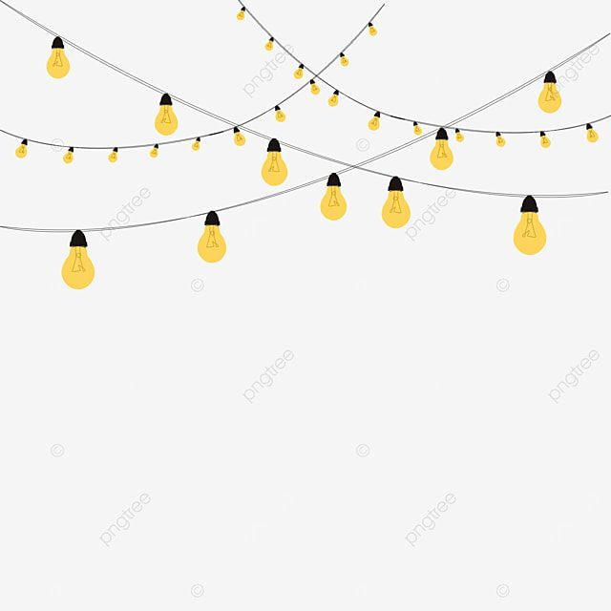
“When the Lights Came On: A Winter’s Night at Nottingham Winter Wonderland”

There’s a special kind of magic that settles over Nottingham when winter rolls in , the kind that glitters under fairy lights, drifts through the scent of roasted chestnuts, and hums with laughter echoing off Old Market Square. The moment you step into Nottingham Winter Wonderland, it’s as if the city’s heart starts to glow a little brighter.
This isn’t just a market or a fair , it’s a frost-kissed playground of wonder, a place where the crisp winter air only makes the warmth of twinkling lights, cozy stalls, and steaming mugs of mulled wine feel even sweeter. From the dazzling Sky Skate Ice Path winding like a ribbon above the crowd to the quaint alpine chalets below, everything here seems designed to wrap you in holiday enchantment Reminds me of( Harry Potter and the Goblet of Fire )

Whether you’re sharing a night with friends, making memories with family, or simply wandering through solo with a steaming cup of cocoa, Winter Wonderland is a place where the year slows down, letting you bask in giddy joy and twinkling delight.
Twinkling Dates And Cozy Hours

• OPENINGS : 12 November – 31 December 2025
• Magic Hours for Wandering: Market stalls Sun–Thu 10:00–18:30, Fri–Sat until ~20:00; evening sparkle extends longer in December
THERE IS NO ENTRY FEE EITHER !!!! YAYYYY

🎡 Glittery Rides & Frosty Fun
- Spin on the Starlit Wheel: Observation Wheel rides ~£8.50/adult
- Glide on the Ice Path: Ice-skating sessions £10–£18, depending on time
- Frosty Bar Adventures: Ice Bar fun ~£19.50 (coat & gloves included!)

🍭 Enchanted Food & Cozy Treats
- Hot Chocolate Clouds: Creamy, dreamy, and sometimes topped with whipped snow—perfect for tiny fingers or grown-up hands seeking comfort. (~£5–£7)
- Gingerbread & Sweet Spells: Houses, cookies, and festive shapes sprinkled with sugar magic (~£3–£6)
- Mulled Wine & Cider: Warming your hands and heart, these classic drinks bring an instant glow (~£6–£7.25 per cup)
- Roasted Chestnuts & Snack Charms: Classic street delights to nibble while wandering (~£3–£5)
- Churros & Cocoa Rivers: Dive into chocolatey goodness with every bite (~£5–£8)
- Market Magic for Meals: Artisan pies, pretzels, sausages, and festive wraps—perfect for a cozy picnic on a bench surrounded by fairy lights (~£6–£12 per dish)

Musicians, and street performers fill the city with music, stories, and laughter that float through every street and corner. The smiles and happy chatter of everyone around make the city feel warm and alive, showing that the magic of Nottingham’s Winter Wonderland isn’t just in the lights, it’s in the people who come together and make the city sparkle. If you haven’t been here before, it’s the kind of place you’ll want to jump straight onto your must-visit list!



